Matches

QUERY

Train

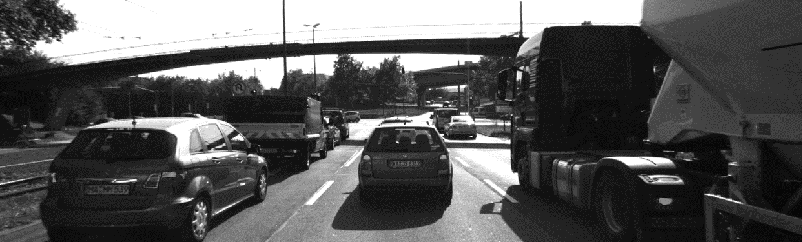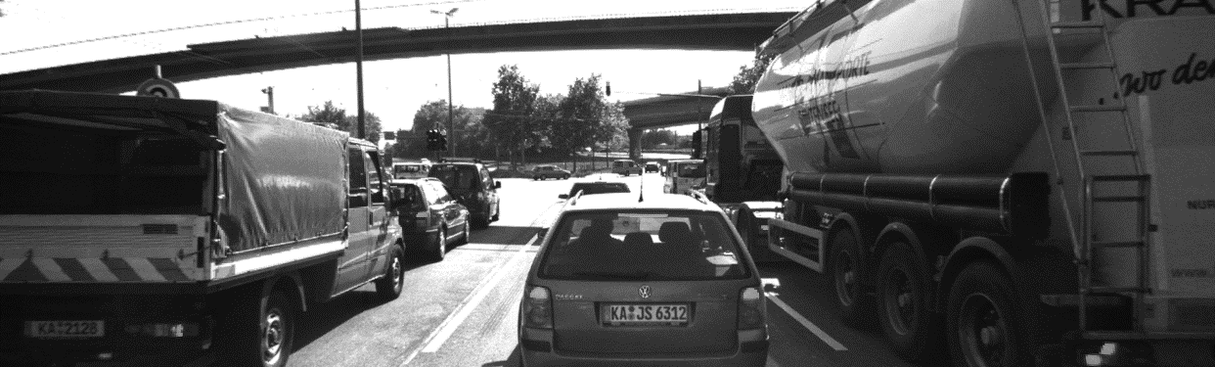

**PrevBoundingBox**

**CurrBoundingBox**

**We Match Points in Each BoundingBox**

**Then return BoundingBox with High Counts**

***clusterKptMatchesWithROI***

we check if Point in this ROI if exist take it if not leave this “match”.

***computeTTCCamera***

we compute distance with every point to other after them

then, get ratio between and take median or mean of these ratios

finally compute TTC.

**computeTTCLidar**

after scanned point we compute TTC, but because there is noise, we take median of this points.